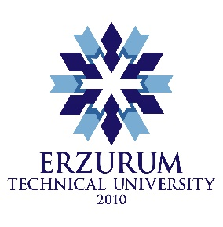
1st Erasmus+ staff week
For
WINTER SPORTS MANAGERS
17th February – 21st February, 2020
Erzurum/TURKEY

Application Form

The working language will be English.
Please send your application form to erasmus@erzurum.edu.tr before 31 January 2020.

host ınstıtutıon

Name of the Host Institution | Erzurum Technical University
Erasmus code | TR ERZURUM02
Contact e-mail | erasmus@erzurum.edu.tr

PERSONAL DETAILS of partıcıpant

First name: | Family name:
Email: | Mobil phone number:
Gender: | Date of birth:

PROFESSIONAL DETAILS

Sending institution (Name – Erasmus Code):

Department/unit:

Address:

Position:

Task description:

MOTIVATION AND EXPECTATIONS

Describe in a few words your motivation in participating in our Staff Week. Why is it important for you to be part of it?

What are your expectations, how will it contribute to your professional career? Are there any specific questions that you would like to get an answer during your visit at ETU?

Date:
Signature:

Please return this application form by e-mail to
erasmus@erzurum.edu.tr before 31 January 2020.

